EXP: 11

1) Populate register number using auto increment in DBMS_Stud table
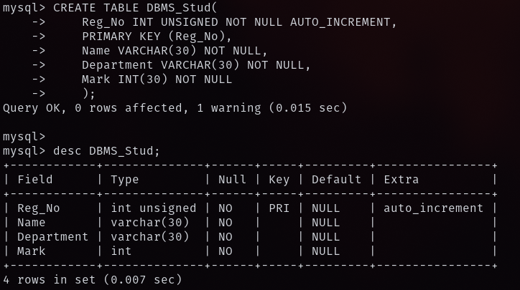
2) Manually populate register number
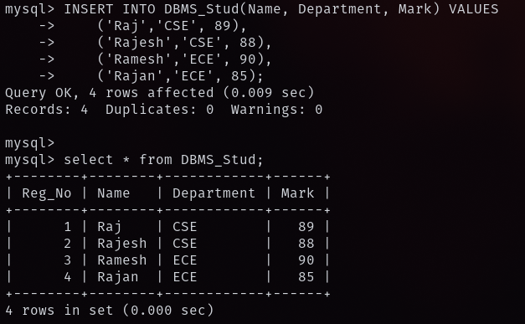

3) Drop the auto increment
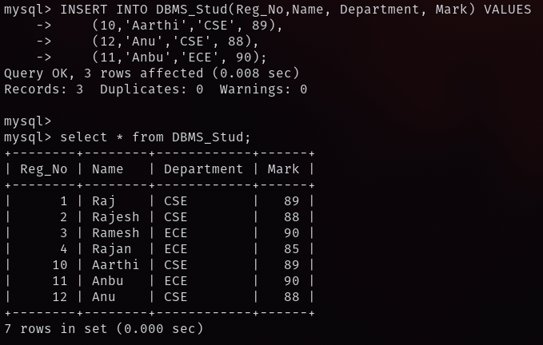
4) Populate register number using auto increment in DBMS_Stud table (output)
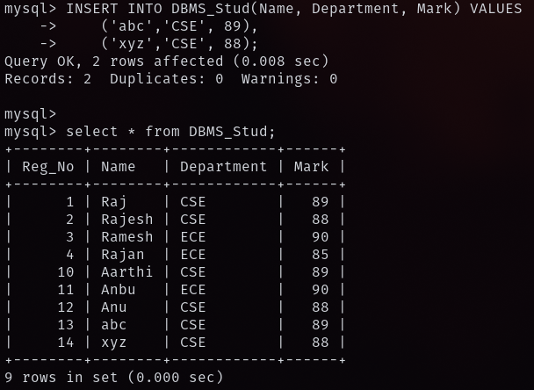

5) Manually populate register number (output)
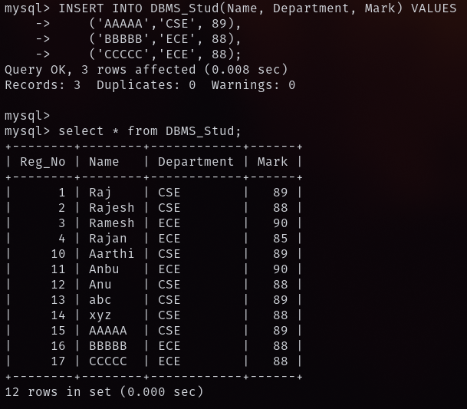
6) Drop the auto increment (output)
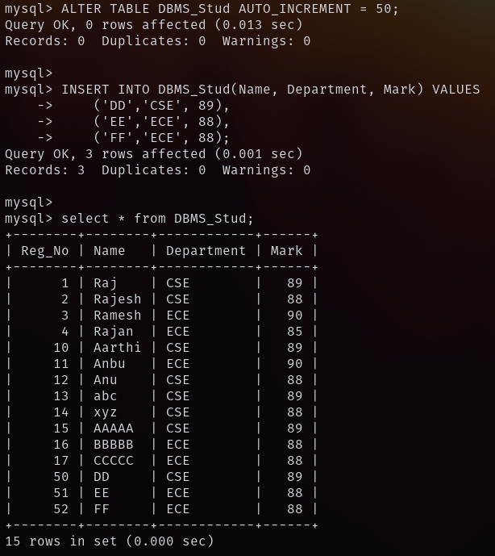
7) Populate register number using auto increment in DBMS_Stud table (output)
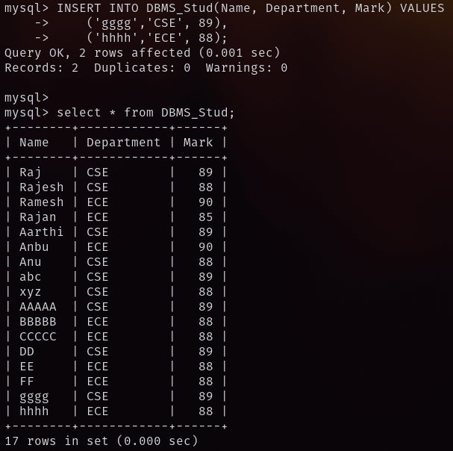

8) Manually populate register number (output)
